|  |  |
| --- | --- |
| **Student Result Management System**  **Submitted by** | |
| T. Prince Charles | PL0621122 |
| Ch. Srinivasulu | PL0621096 |
| Ch. Girisha | PL0621114 |
| M. Priyanka | PL0621121 |
| P. Raghuveer | PL0621105 |
| T. Rajitha | PL0621113 |

**Table of Contents**

1 Abstract 3

2 Introduction 4

3 Scope of Change 5

4 List of Pages 6

* Admin Login Page 7
* Admin Home Page 8
* Student Login Page 9
* Student Home Page 10

5 List of Modules 11

* Add New Student 12
* Insert New Result 13
* Registered Students 14
* All Student Result 15

6 Diagrams 16

7 Advantages 23

8 Improvements 23

9 Hardware and Software Requirements 24

10 Conclusion 25

11 References 26

**Abstract**

The Purpose of Student Result Management System is to automate the existing manual system by the help of computerized equipment’s and full-fledged computer Software, fulfilling their requirements.so that their valuable data information can be stored for a longer period with easy accessing and manipulation of the same. The required software and hardware are easily available and easy to work with. Student Result Management System, as described above can lead to error free, secure, reliable and fast Management System. It can assist the user to concentrate on their activities rather to concentrate on the record keeping. The organization can maintain computerized records without redundant entries. That means that one need to be distracted by information that is not relevant, while being able to reach the information. The essence is designing an efficient computerized system will replace manual result processing which is prone to lot of paper work and errors. This reduces the tedious tasks involved, and enhance student’s performance through timely publication of results

**Introduction**

The Project Student Result Management System which is implemented by using JSP (Eclipse, Tomcat, MySQL). The main objective of the project is to provide the examination result to the student in a simple way. Student report generator is a web-based application designed and engineered for colleges that need to manage results across multiple branches students that need to track, manage and report results. This application can run on any kind of operating system. At a time we can see all the years result in a single sheet and we can see the individual candidate’s results separately. By a result analyzer with subject status and marks is an application tool for displaying the results in secure way. The system is intended for the student. The whole result analyzer will be under the control of the administrator and the admin as the full privileges to read, write and execute the result. Student Result Management System project documentation or project report covers detailed explanation of every module with explanation of working principle, software and hardware requirements, block diagrams, sequence diagram, database design, database tables.

**Scope of Change**

The study aims at developing and implementing a student result management system. The old manually done paper work and to minimize the security issues and the problems it possesses. The proposed is a multi-user system, developed using Java programming language with Apache Tomcat Server and MySQL support. The system is confined to and intended for the students. They possess privileges to check their results after he/she is provided with a specific Roll no for a secure login. The entire system is managed by a system administrator, who possesses the full control of the system, to read, write and execute the results and to assign privileges to teachers and students. And the teachers have the privilege to assign the students’ marks, through which, a result will be generated automatically and each student will have access to their results only, using their respective account.

**List of Pages**

* Admin Login Page.
* Admin Home Page
* Student Login Page.
* Student Home Page.

**List of Modules**

* Add New Student.
* Insert New Result.
* Registered Students.
* All Student Result.

**Admin Login Page**

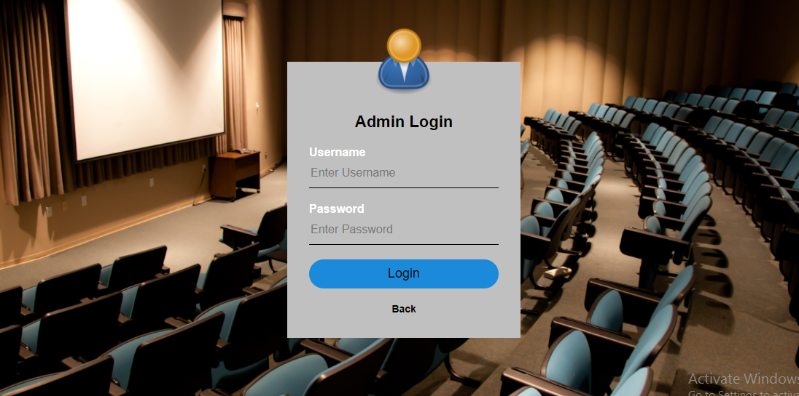

This Picture describes how an admin can login into the portal.

* The admin has to login into the portal.
* After the successful login, will go to Admin page.
* The following information is required during Admin Login is User Name and Password.
* The system will validate the information provided.
* If any invalid data is found, the input form will be redirected with error message.
* Password is required and minimum 1 character.
* User Name can be Admin Name.
* User should have network access and Browser with latest updates.

**Admin Home Page**

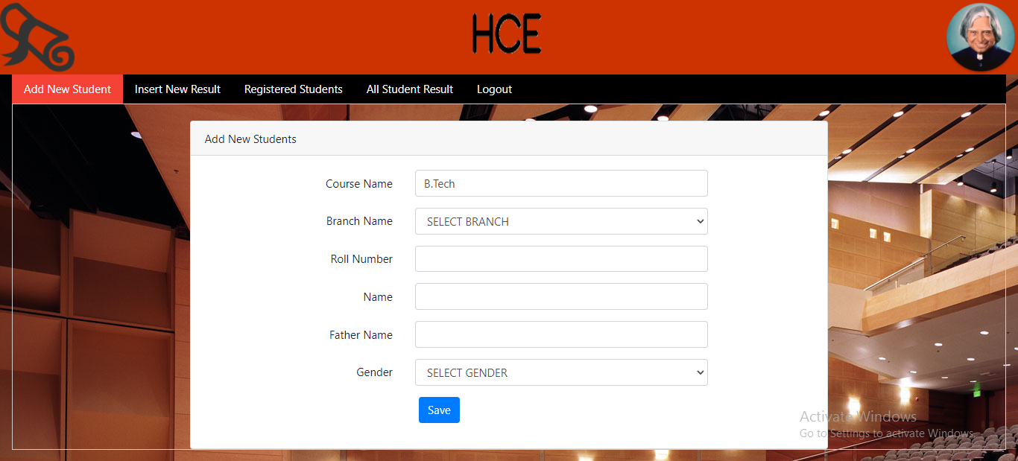

These are the Modules present in this page.

**Add new student:** Add new Student is for adding the new student details.

**Insert new result:** Insert new result is for adding marks of the student using student roll number.

**Registered Students:** Registered Students is for displaying the all student details.

**All student Result:** All Student Result is for displaying all student subject marks.

**Logout:** We can go back again to admin login page and finally home page.

**Student Login Page**

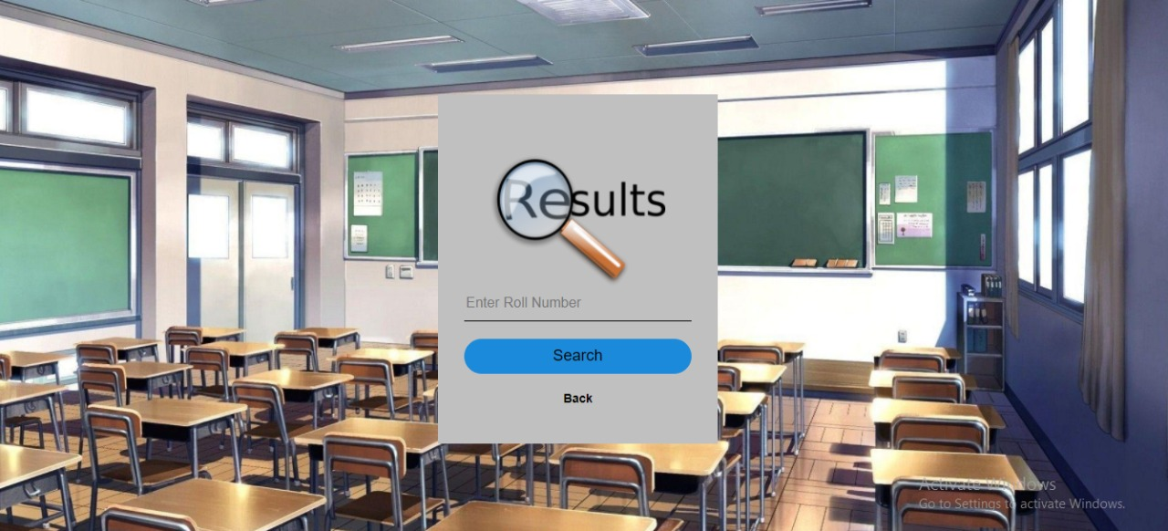

# In this page the student can login with his/her unique roll-no

# **Student Home Page**

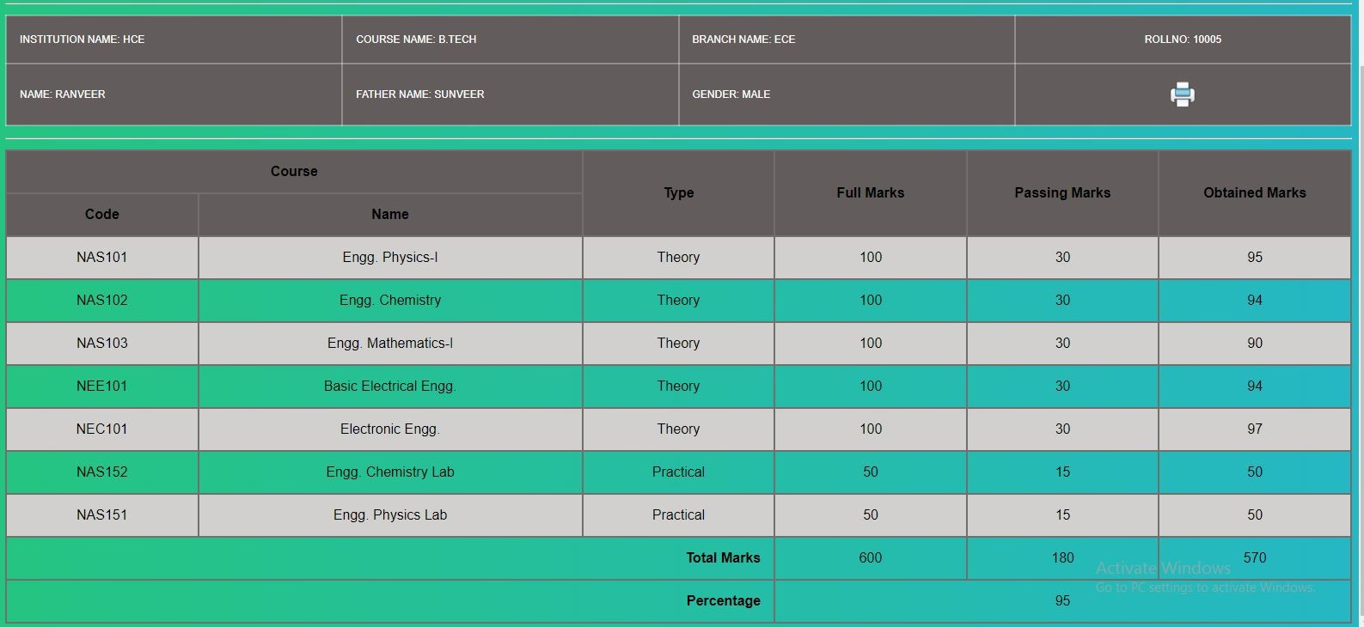

# Here we can see the full marks and result of the student clearly.

# Percentage of the student and details are also displayed here.

**Add New Student**

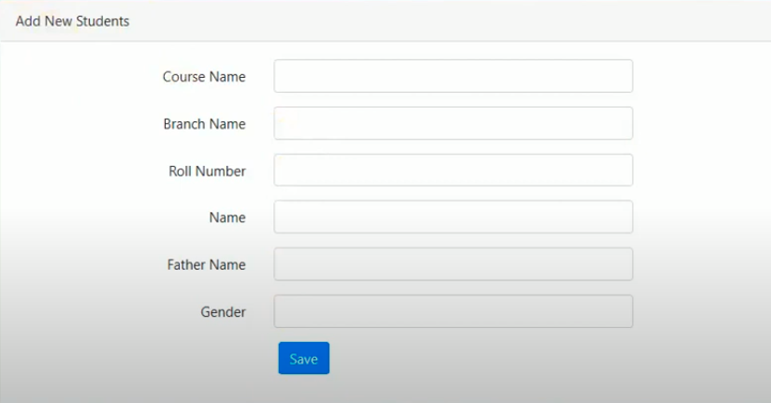

* In this system new student can be added by entering student details
* Admin need to enter the Student details like Course name, Branch name, Roll number, Name, Father Name and Gender.
* After adding all the details we can click on the save button to save the details of the student.

**Insert New Result**

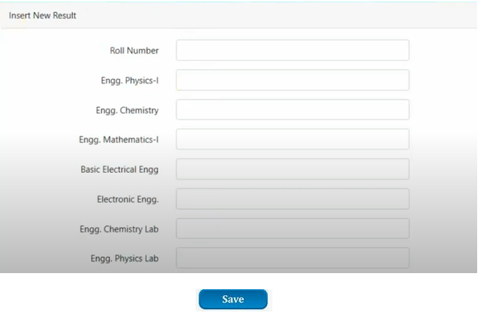

* The Admin should login into the system with unique her/his username and password.
* If the user name and password are valid then he can gain access to the system.
* With the specific Roll-no of the student we can add all the subject marks.

**Registered Student**

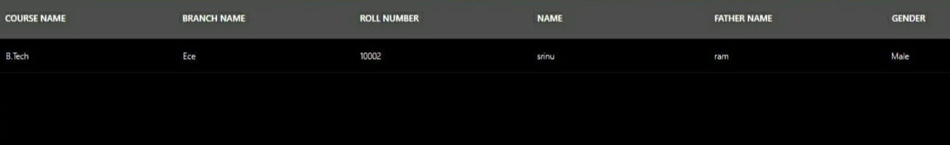

* In this new student marks of all subject and result can be updated.
* In which we can have course name, branch name, Roll Number, Name, Father Name and Gender.
* So Particular data can be registered.

**All Student Result**

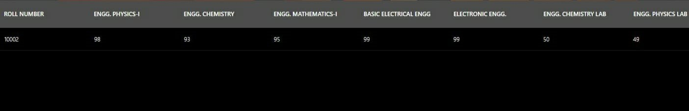

* In this new registered student and already added student result can be visible.
* Here we can see all the students’ results with a particular Roll Number.
* So it is easier to the admin to access all the student results.

# **Diagrams**

# **Welcome Page: -**

# 

**Student Home page: -**

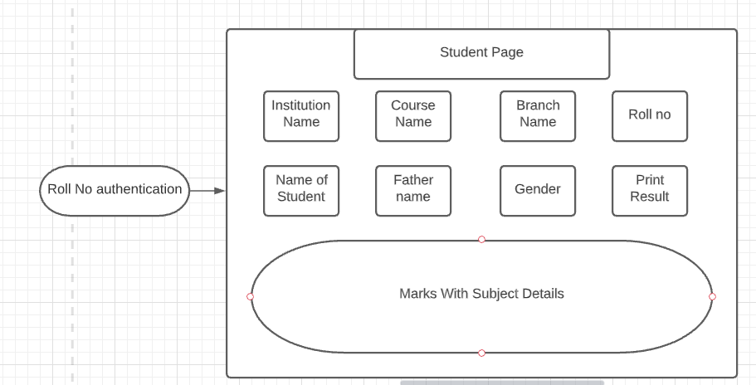

**Admin Login Page: -**

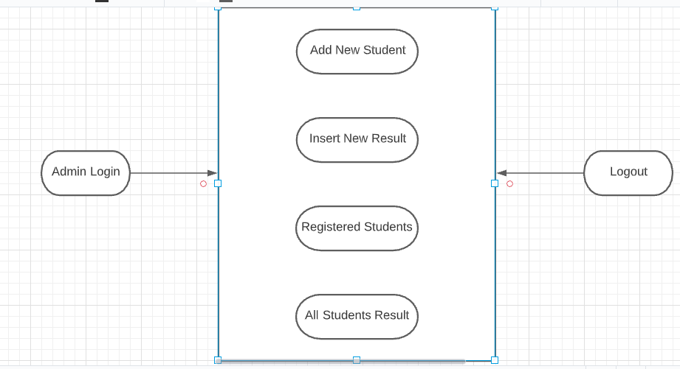

**Admin Use Case Diagram:-**

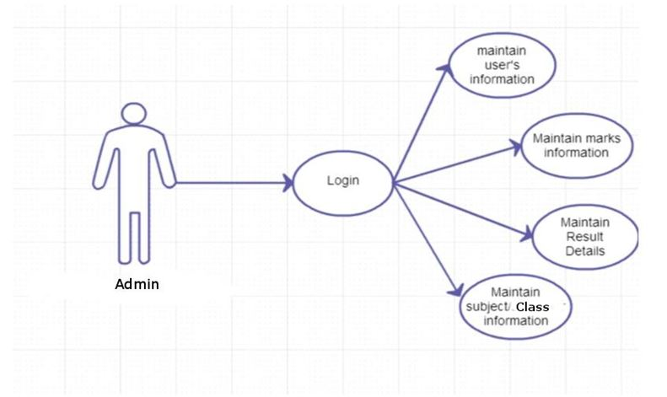

**Student Use Case Diagram:-**

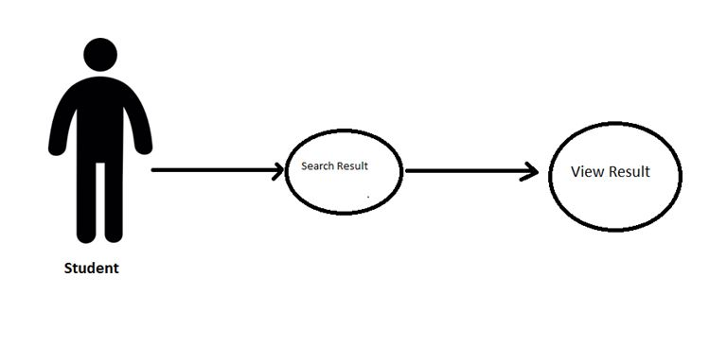

**Relationship diagram Between Tables:-**

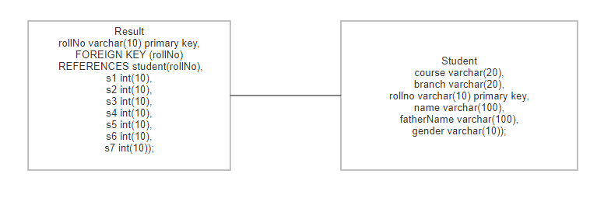

**Admin ER Diagram:-**

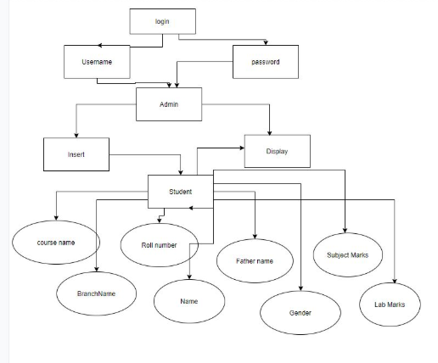

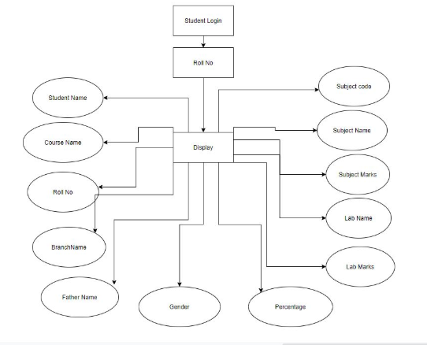**Student ER Diagram:-**

**Advantages:**

* With student result management system, teachers, professors, and staff can create result analysis reports.
* Student results and details are stored in a single database.
* Add & manage students and Declare Results.
* Calculate scores, percentages and grades.

**Improvements:**

* In the future the system interface could be improved.
* Enhancing the system with an Email and SMS notifications.
* Enhancing the current system by computerizing almost all the services provided by the institution.
* And evolving the system by developing several versions through user’s feedback.
* This can be adapted to any institution regardless the field of study.
* We can include Grade book Management.

**Software Requirements**

* Operating System: Windows 10
* Server Side: JSP with Tomcat Server
* Client Side: HTML, JavaScript, CSS
* Services: JDBC
* Database: My SQL
* Integrated Development Environment: Eclipse Mars

**Hardware Requirements**

* Ram: 64MB (or) Higher
* Cache: 512MB
* Hard disk: 10GB
* Processor: I-3
* Generation: 8th Generation

**Conclusion**

Student Result Management System can be used by educational institutions to maintain their student records easily. This application will greatly simplify and speed up the result preparation and management process. Achieving this objective is difficult using the manual system as the information is scattered, can be redundant, and collecting relevant information may be very time-consuming. All these problems are solved by this project. It provides the examination result to the student in a simple and accurate way.

This system helps in maintaining the information of pupils of the organization. It can be easily accessed by the manager and kept safe for a long period of time without any changes.

**References**

<https://www.w3schools.com>

<http://www.javatpoint.com>

<http://www.tutorialspoint.com>

<http://www.geekforgeeks.com>

<Http://www.coderanch.com>

<Http://www.stackoverflow.com>